JAVA PROGRAMS

PROGRAM 1:
MULTIPLE OF 3
PROGRAM:
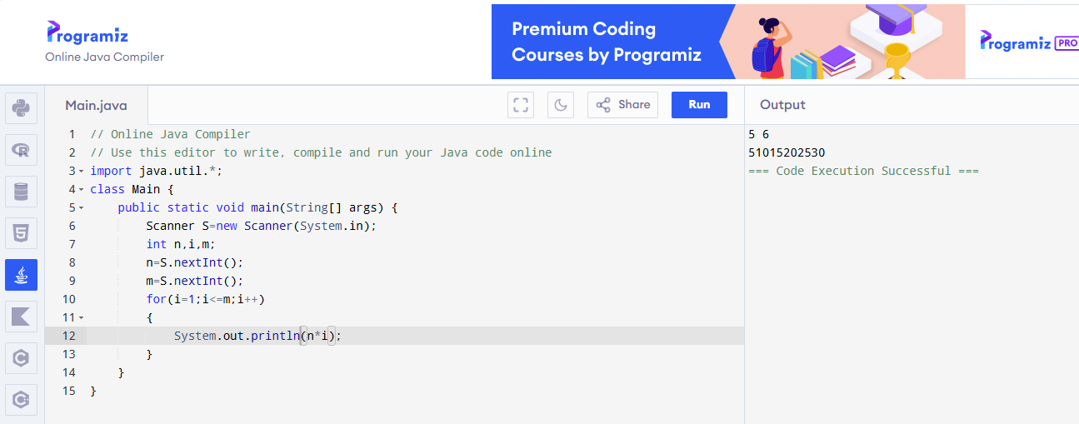

PROGRAM 2:
NUMBER DIVISIBLE BY 4
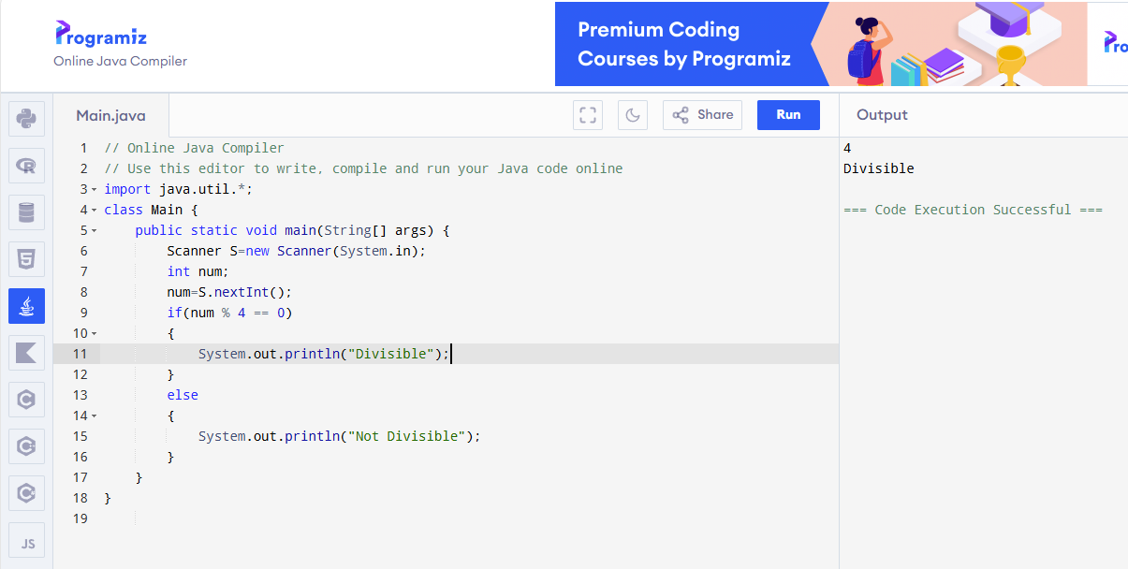

PROGRAM 3:
CHECK PASS OR FAIL
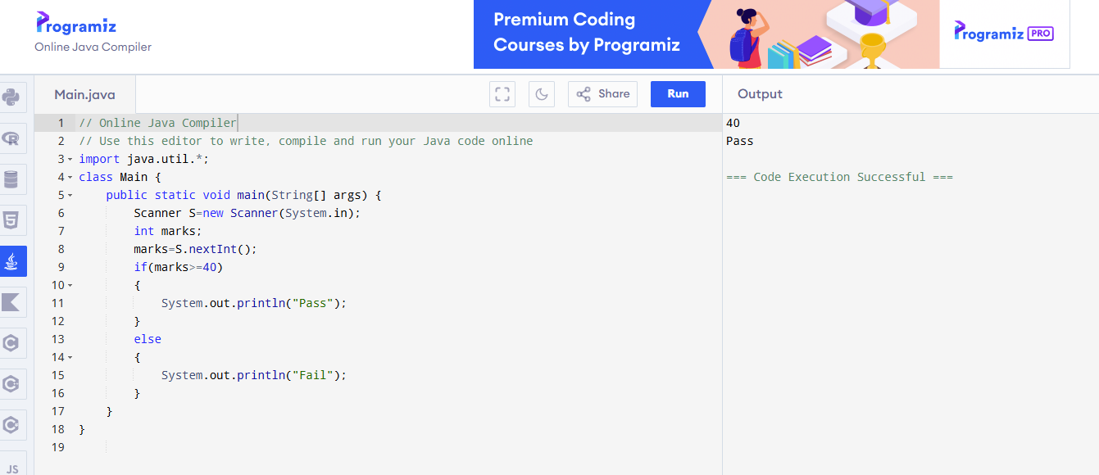

PROGRAM 4:
CELECIUS
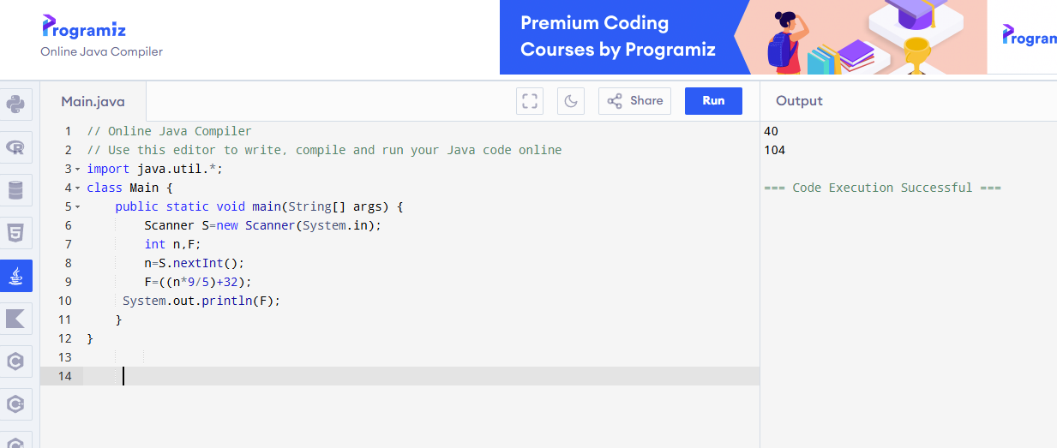

PROGRAM 5:
PREMETER OF A RECTANGLE
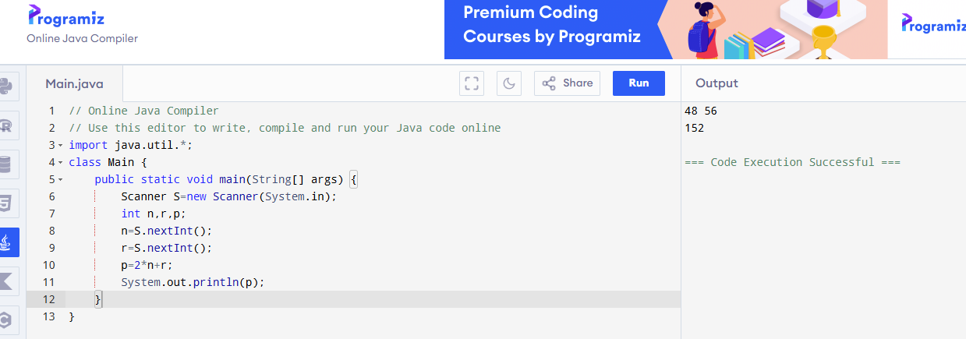

PROGRAM 6:
ADD 10 TO A NUMBER

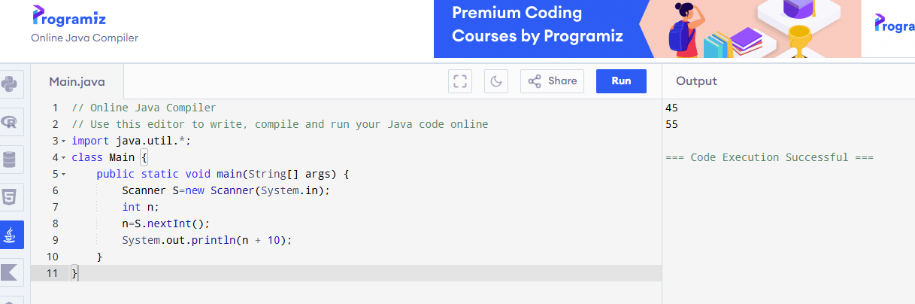

PROGRAM 7:
FIND A LARGEST NUMBER
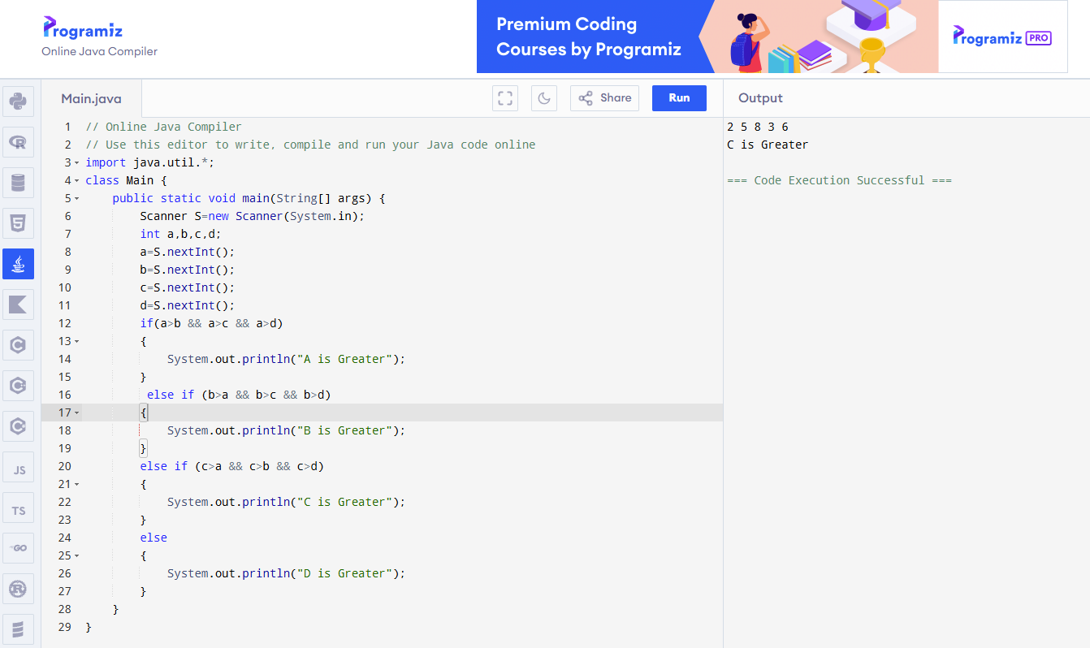

PROGRAM 8:
NUMBER IS GREATER THAN 100
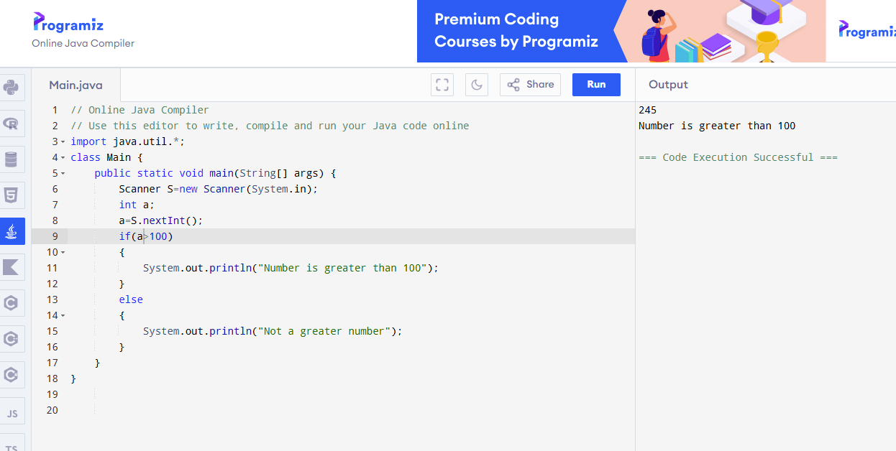

PROGRAM 9:
THE AVERAGE OF 4 NUMBER
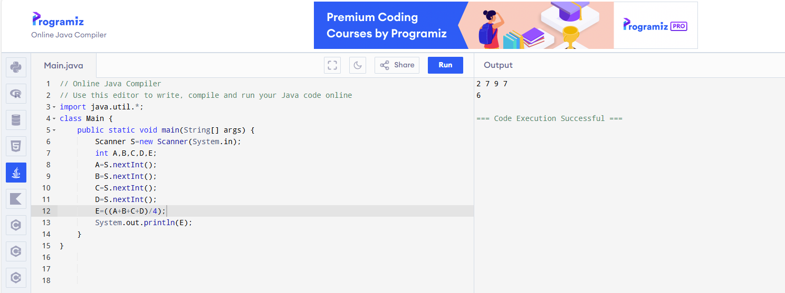

PROGRAM 10:
NEXT NUMBER
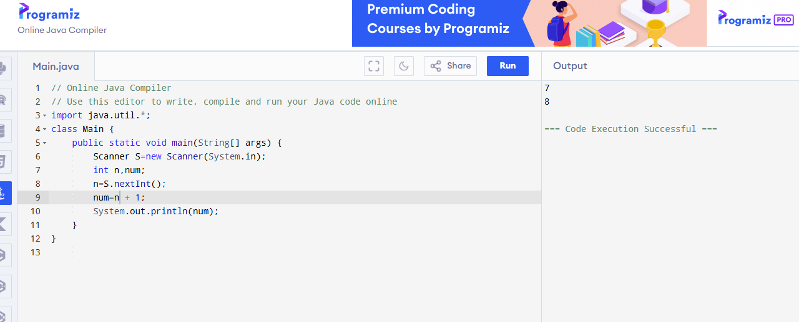

PROGRAM 11:
FACTORIAL OF A NUMBER
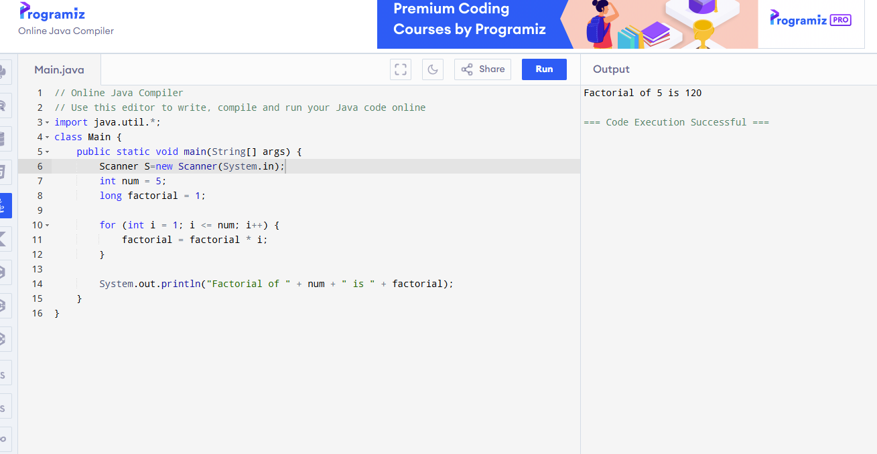

PROGRAM 12:
COUNT DIGITS IN A NUMBER

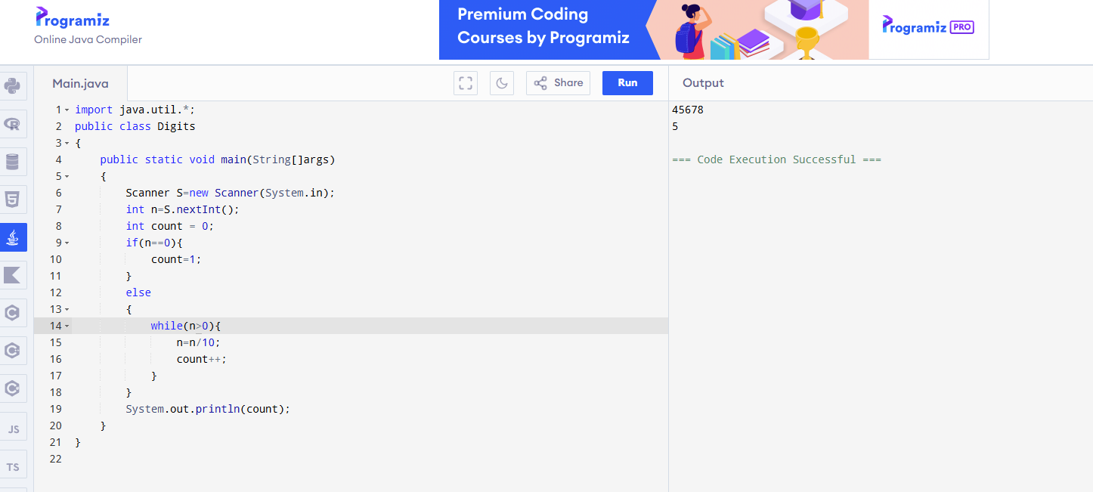

PROGRAM 13:
SUM OF ODD NUMBERS
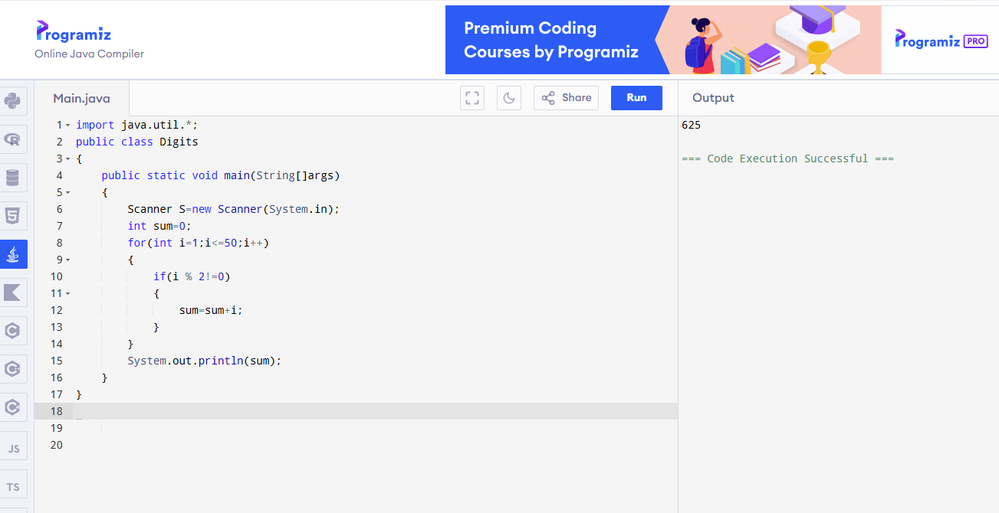

PROGRAM 14:
SUM OF DIGITS
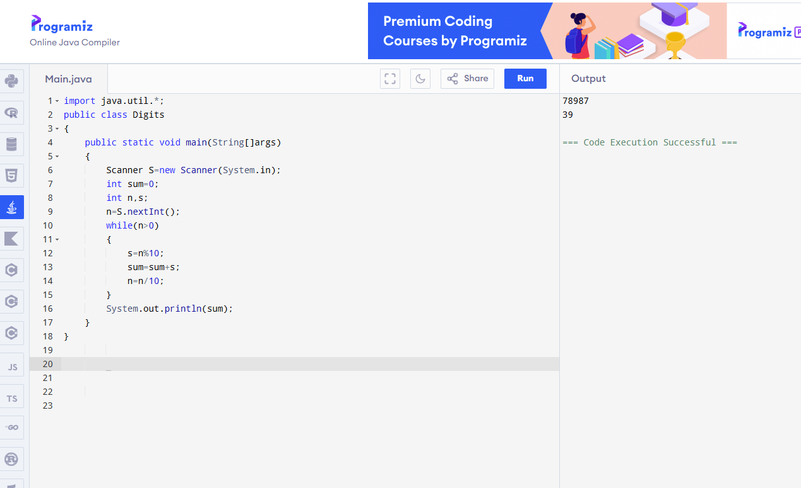

PROGRAM 15:
REVERSE A NUMBER
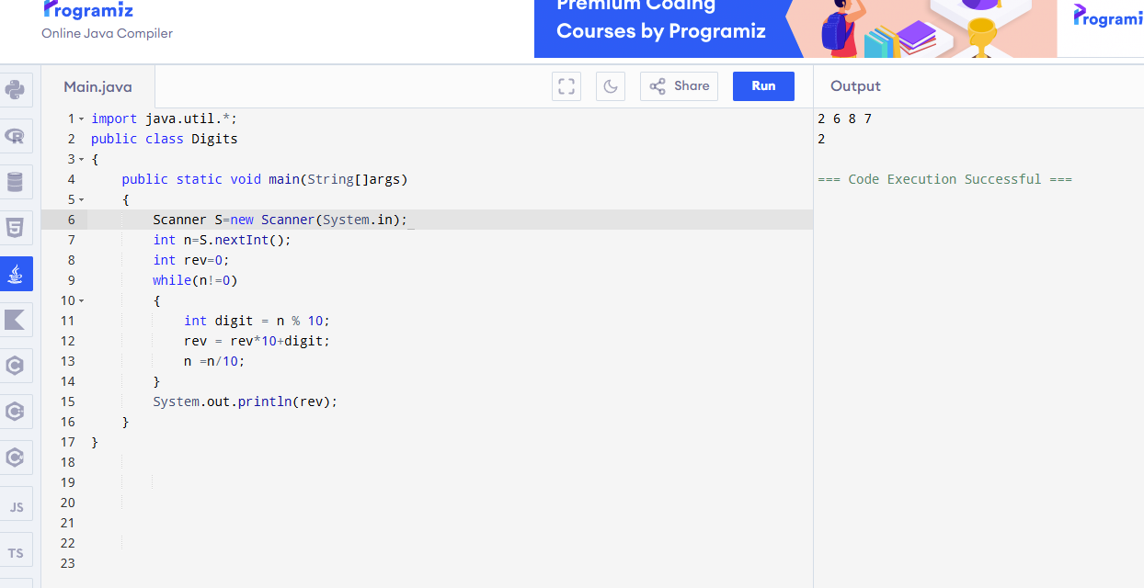
PROGRAM 16:
COUNT EVEN NUMBER FRIM 1 TO N
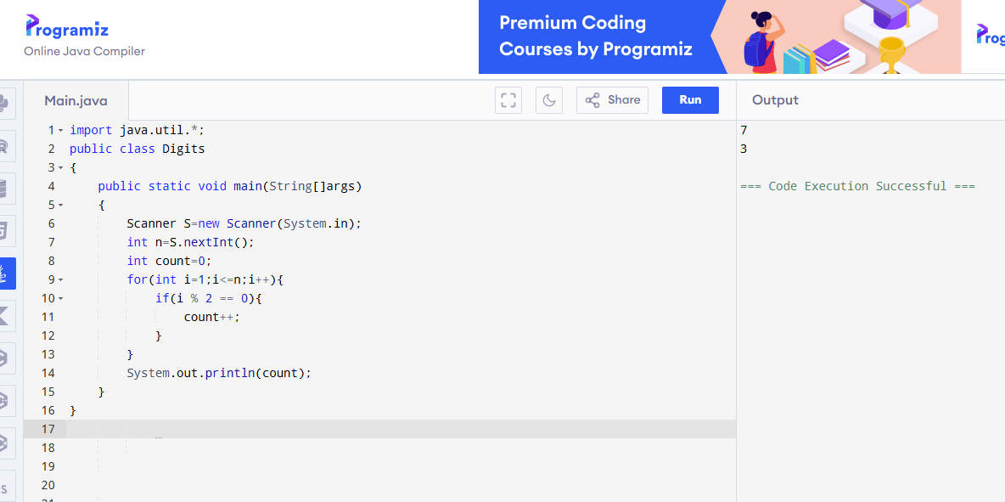

PROGRAM 17:
PRINT DIGITS GREATER THAN 5
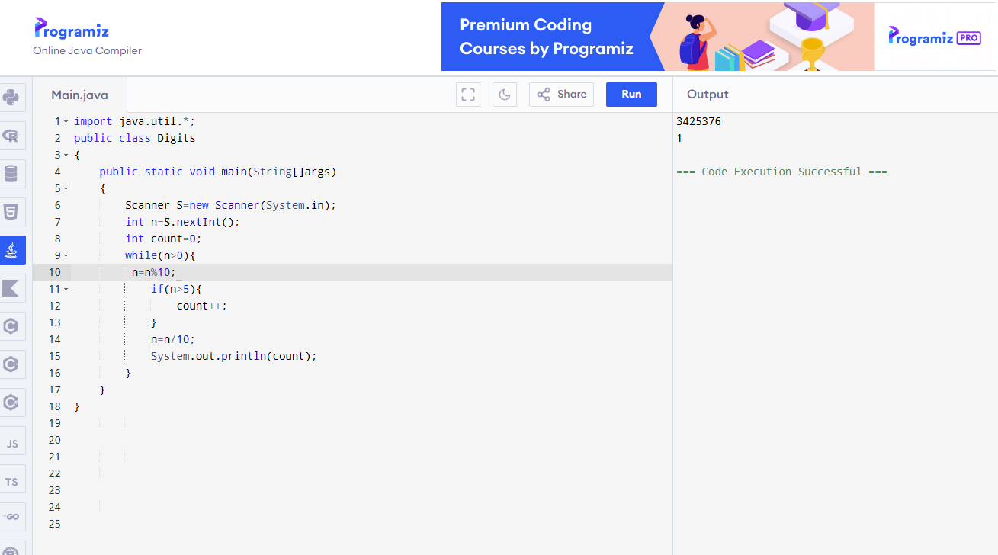
PROGRAM 18:
COUNT ZEROS IN A NUMBER
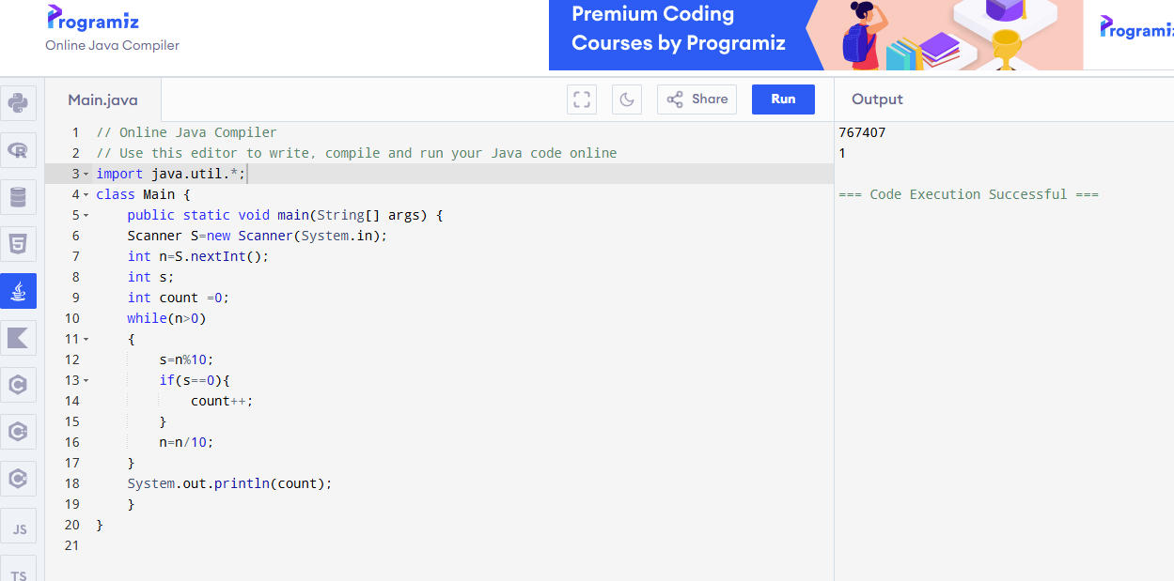

PROGRAM 19:
PRINT EVEN NUMBER FROM 1 TO N
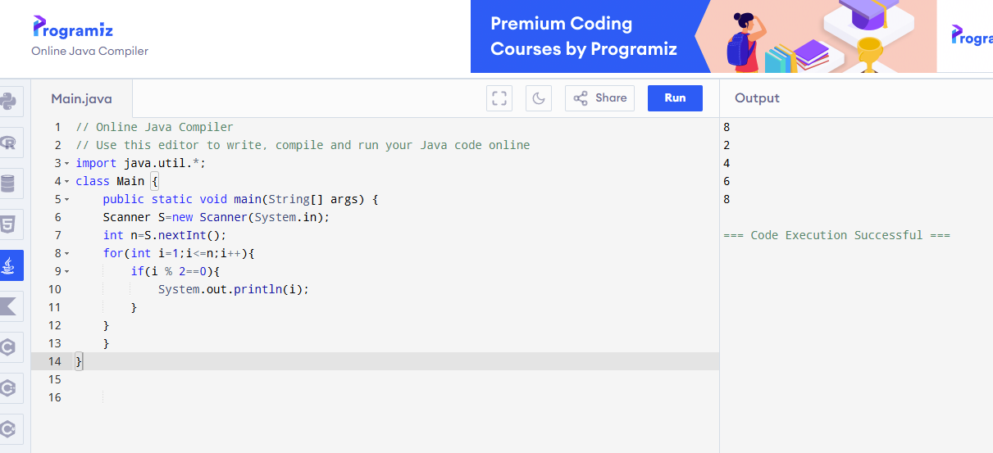

PROGRAM 20:
PRINT ODD NUMBER FROM 1 TO N
